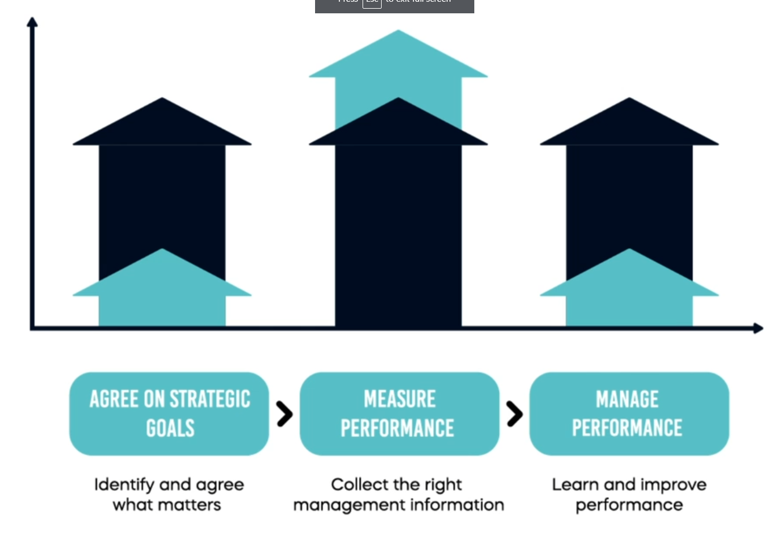

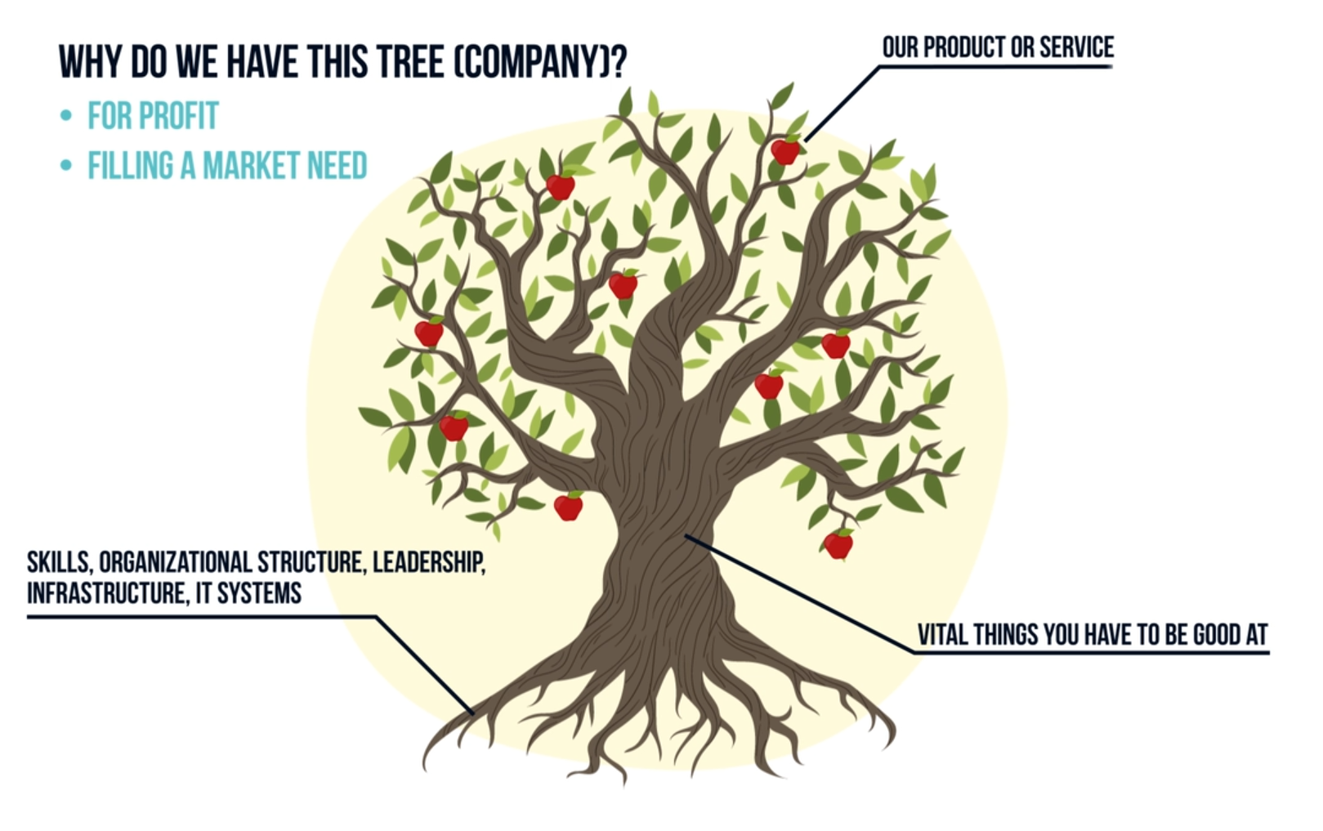

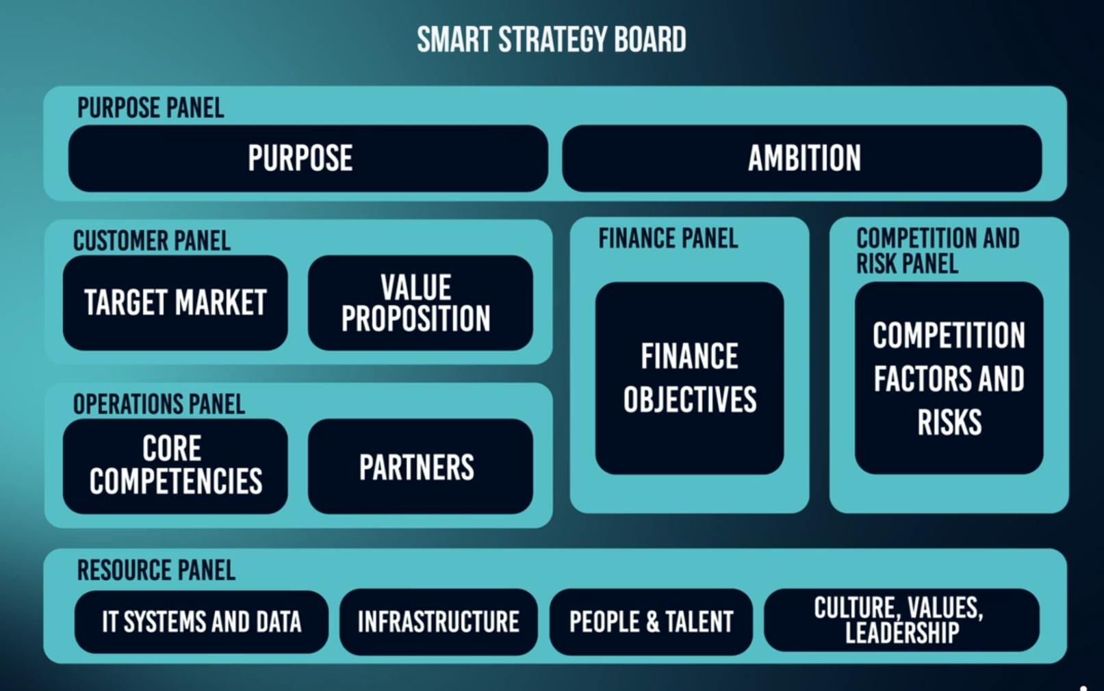

PURPOSE PANEL

Purpose : why do you exist as an organization

Ambition : where do you want to get in future?

CUSTOMERS PANEL : we need to identify a goal ( 1- 3 strategic goals)

OPERATIONS PANEL: figure out what we are good at

FINANCE PANEL : traditional goals around growing revenue, profitability and reducing costs

COMETITOR AND RISK PANEL : (9 -15 strategic goals)

. Who are the key competitors?

. What are the market challenges?

. What are the macroeconomic challenges?

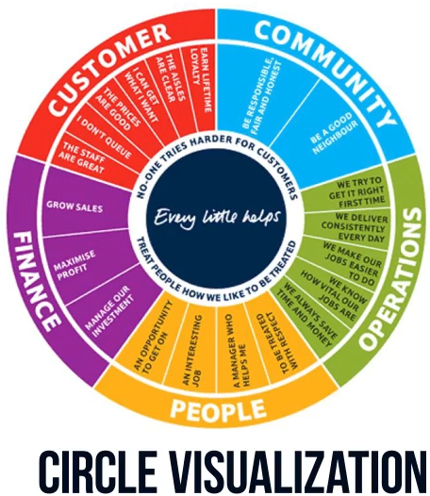

Difference between goals vs kpi vs target

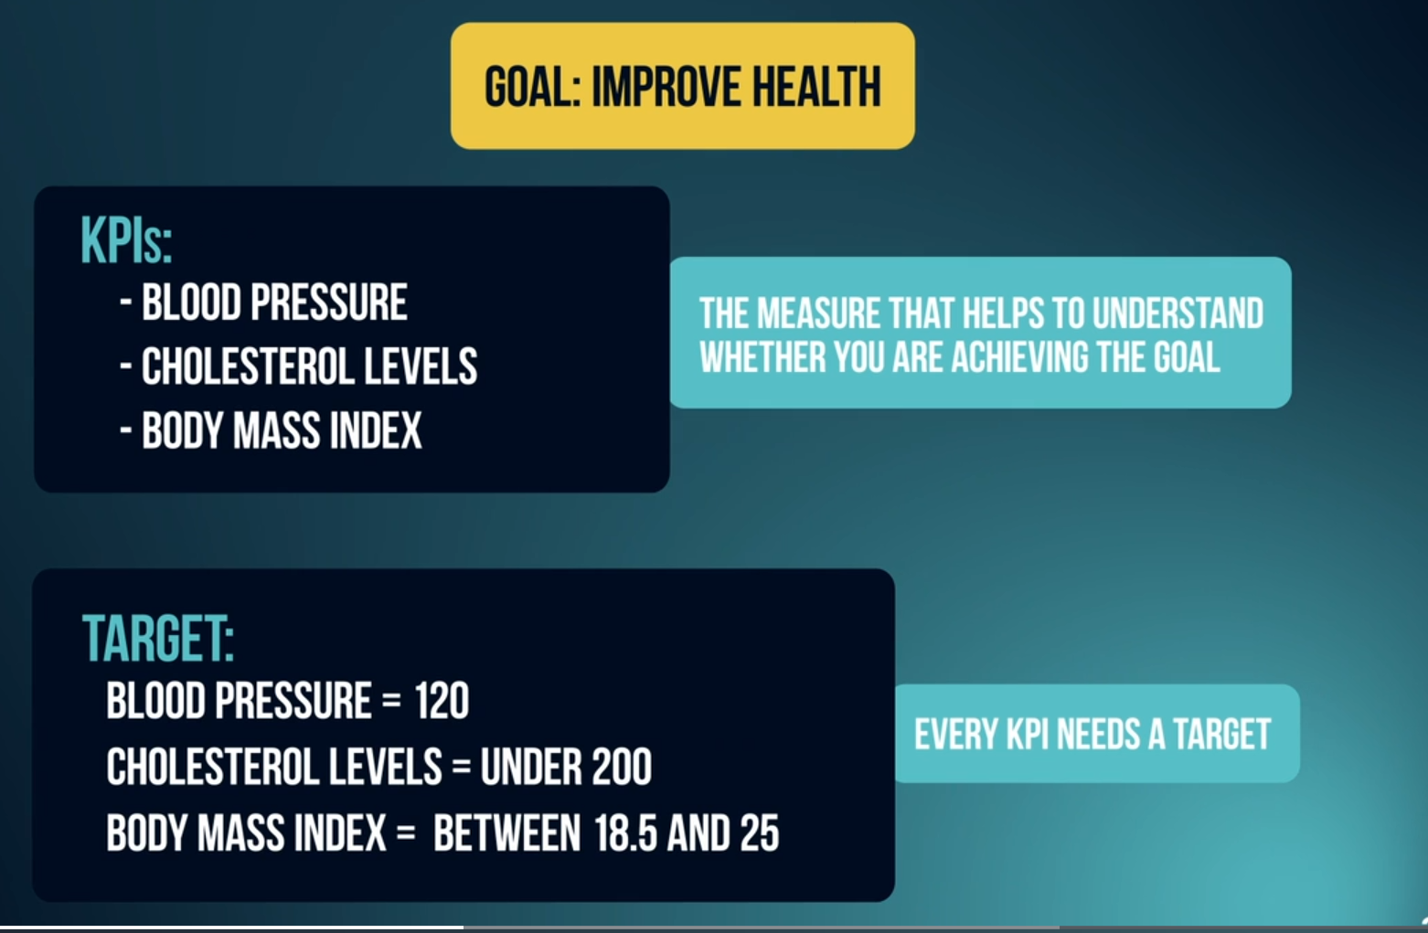

Finding valuable kpis

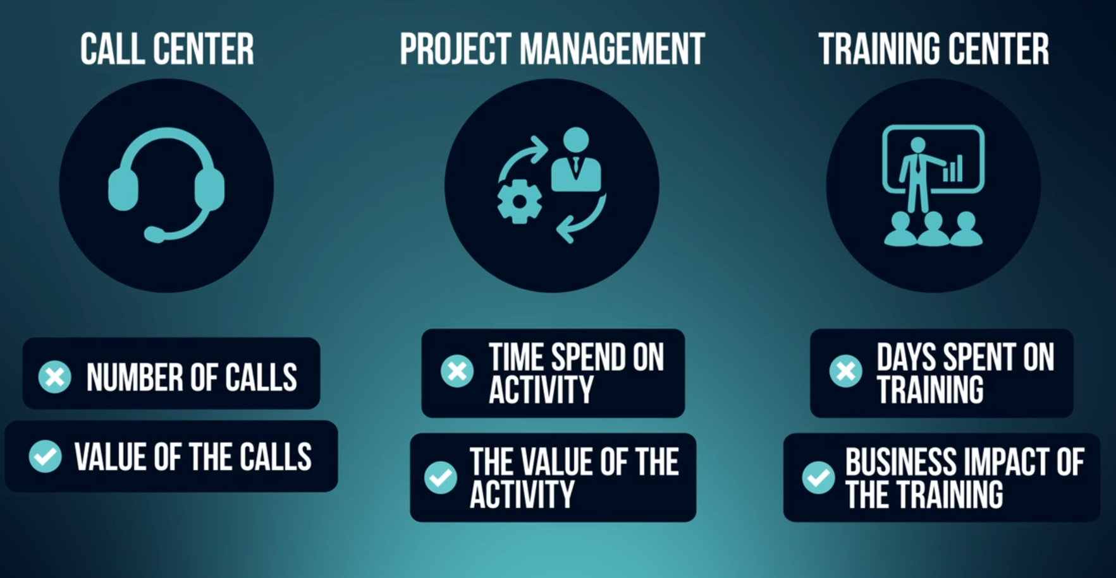

Operational KPIs example

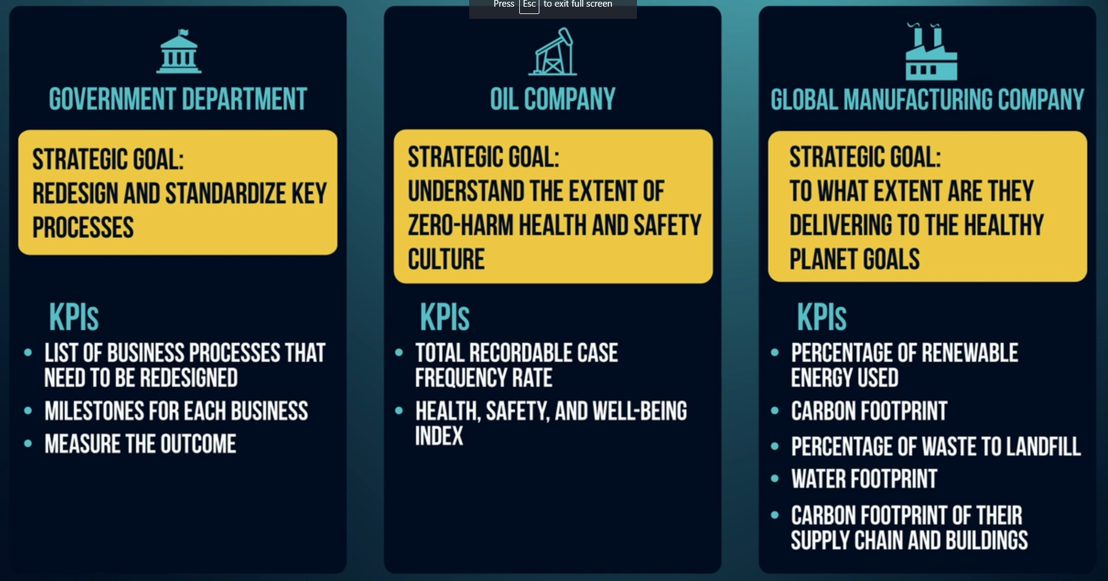

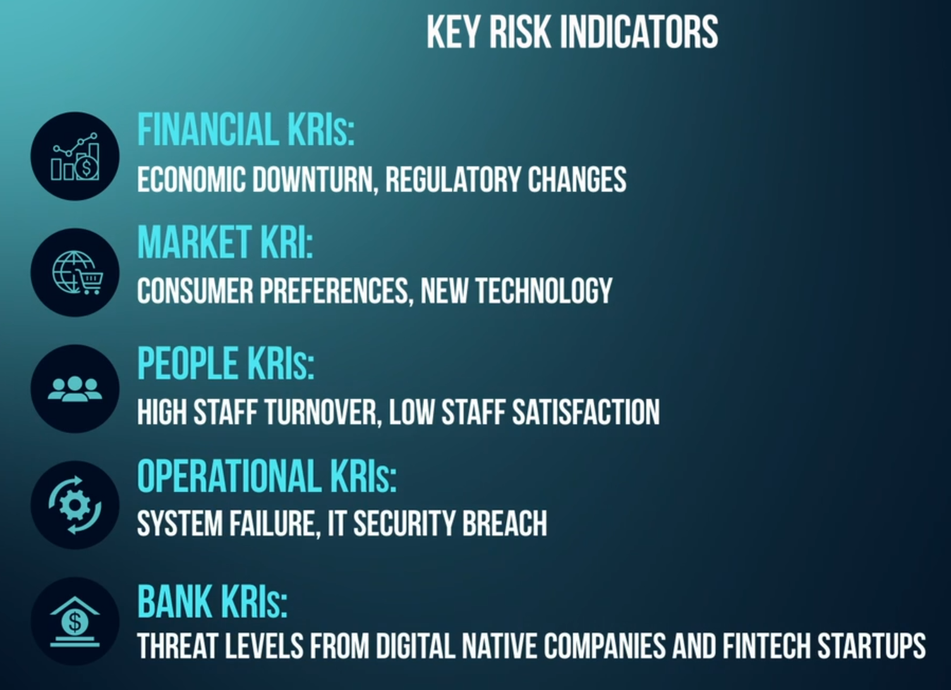

Example of report

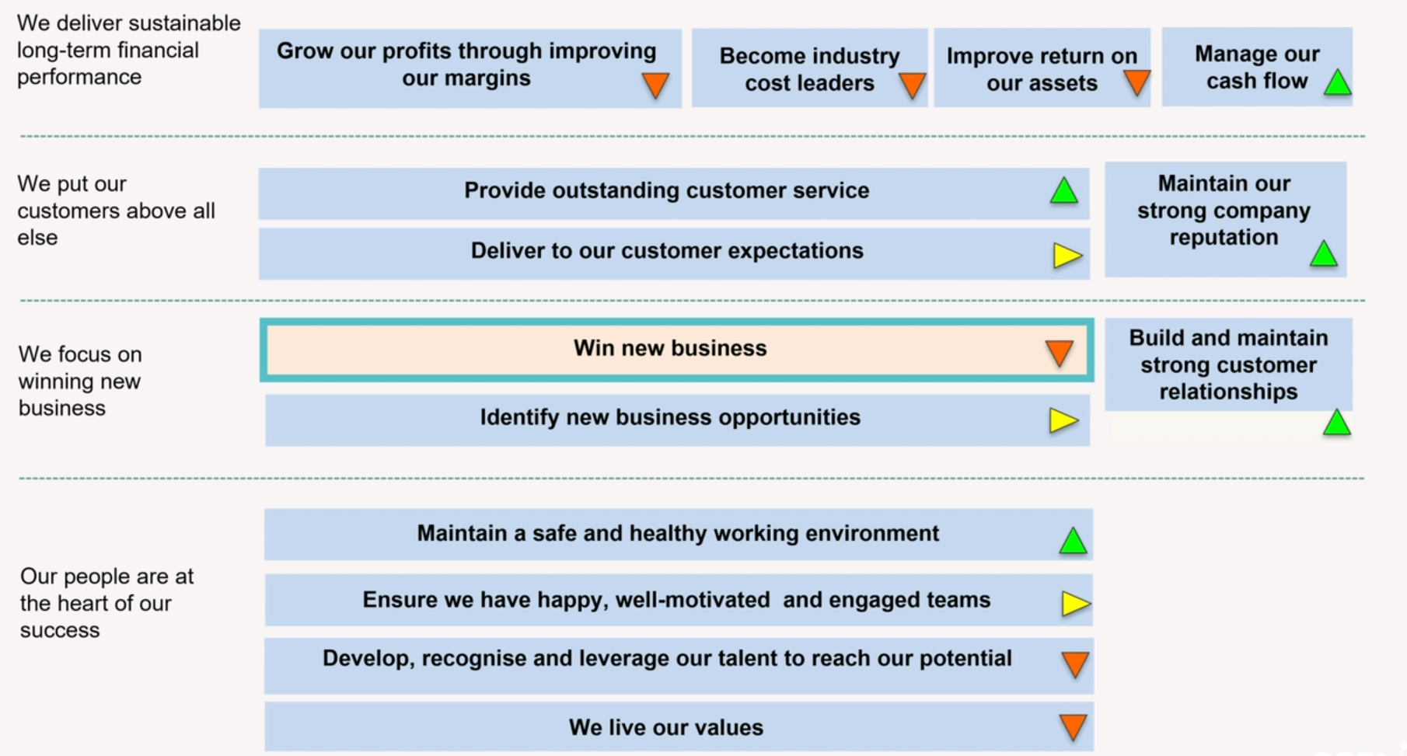

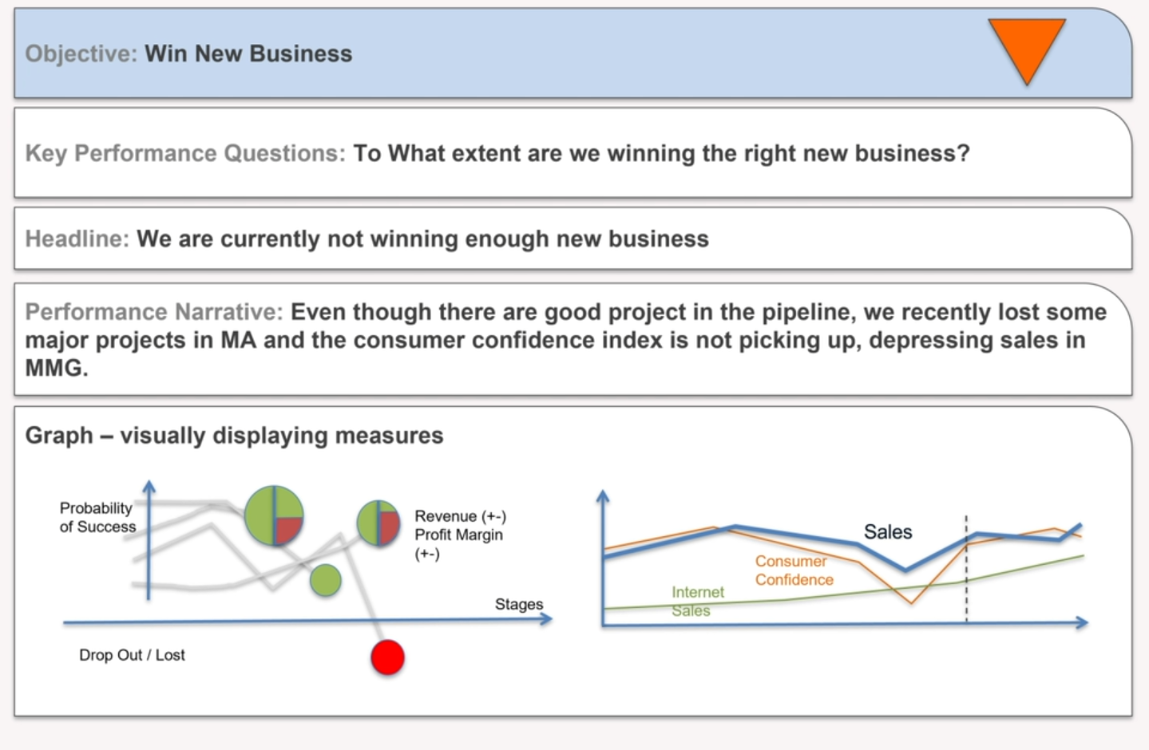

Meetings

